1. GET vehicles - http://192.168.0.4:8080/RESTfulCRUD/rest/v1/vehicles/

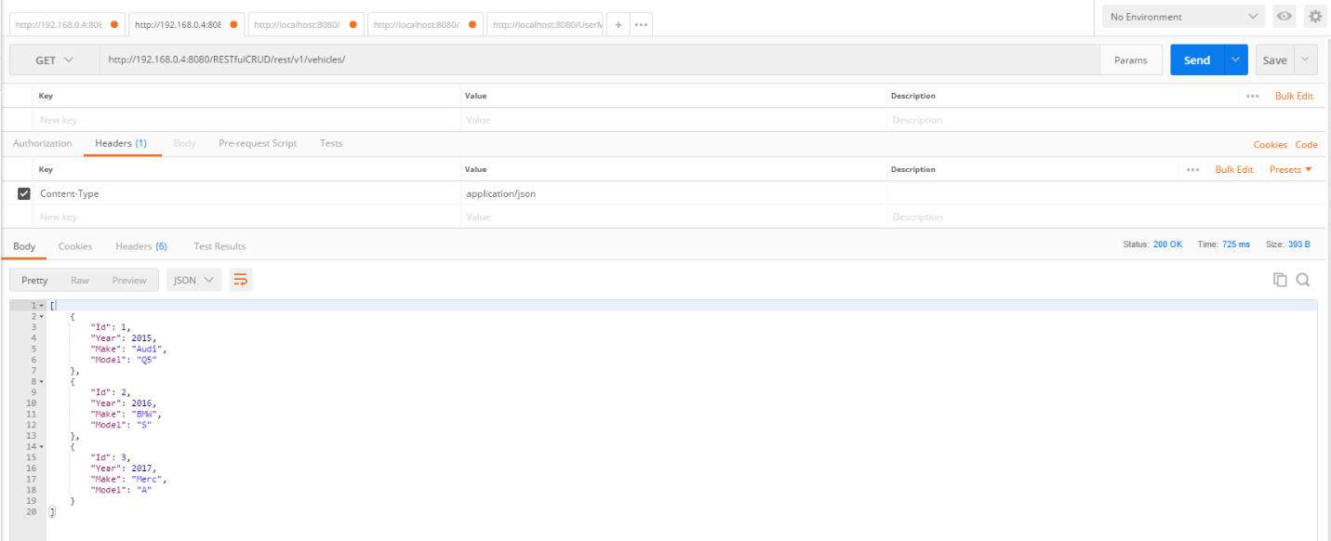

2 GET vehicles/{id} – http://192.168.0.4:8080/RESTfulCRUD/rest/v1/vehicles/1

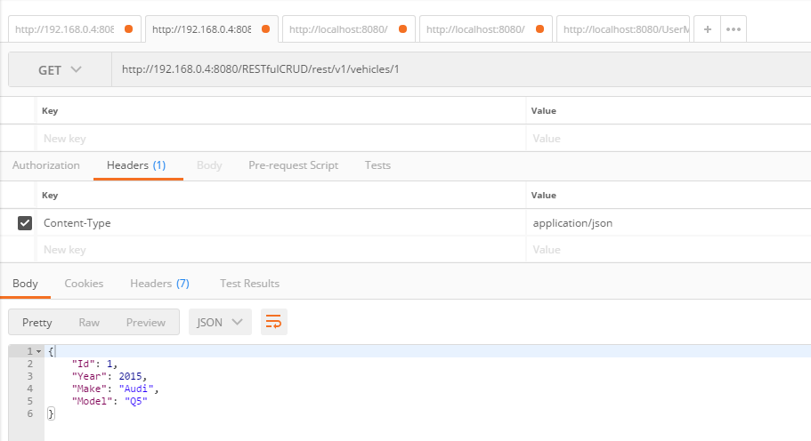

3. GET Vehicles/Year/{Year}/Model/{Model}

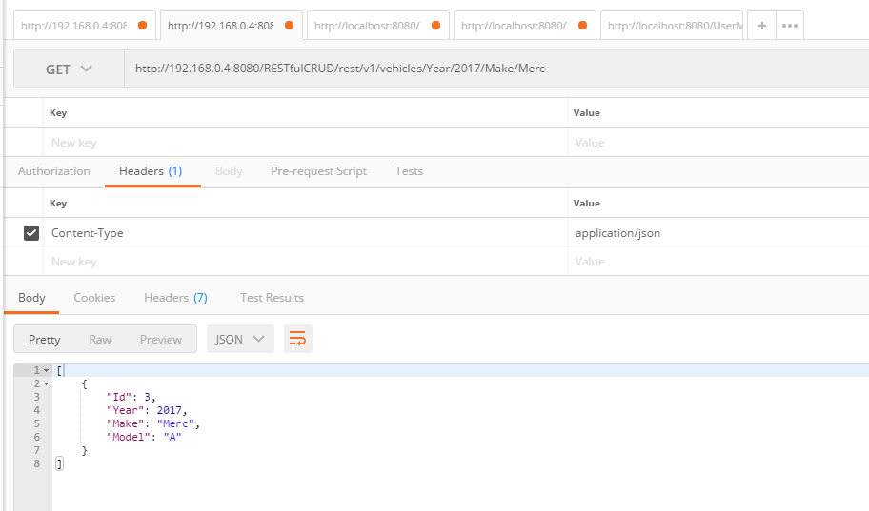

GET Vehicles/Year/{Year}/Make/{Make}

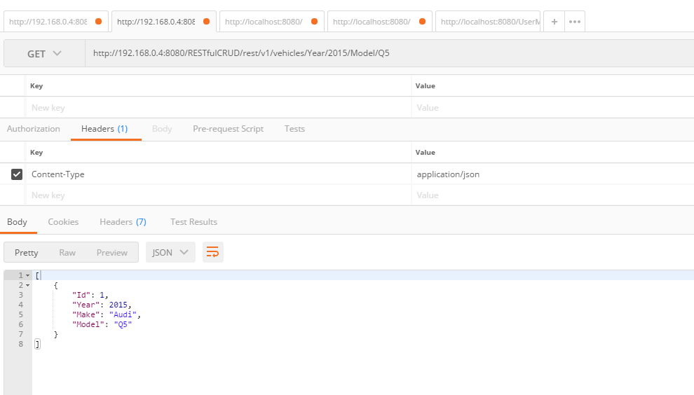

GET Vehicles/Make/{Make}/Model/{Model}

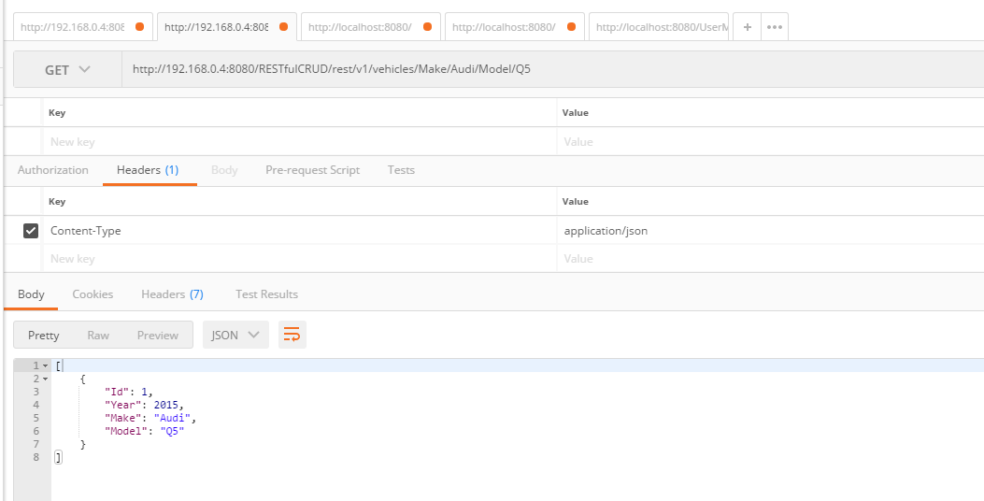

POST vehicles

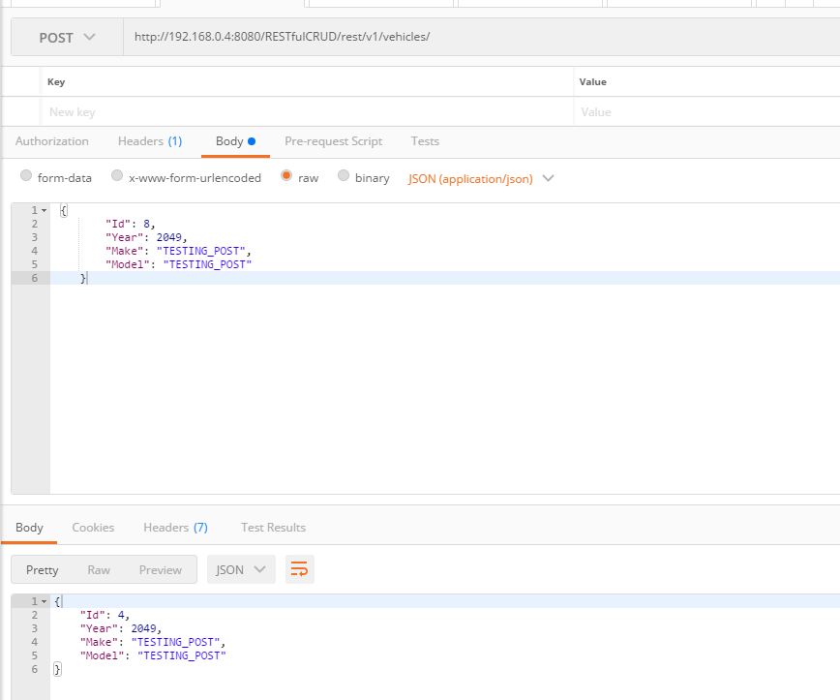

PUT vehicles

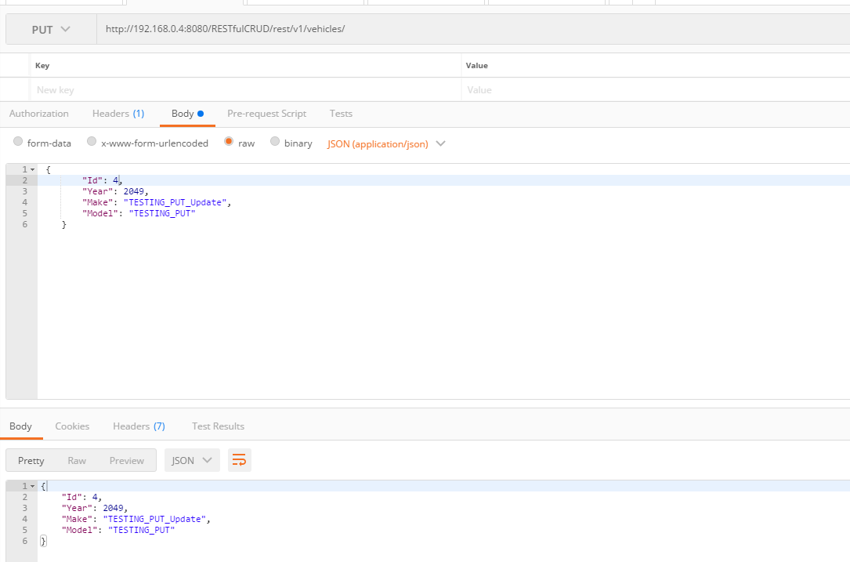

DELETE vehicles/{id}

